In [1]:

*#Pawar ved balasaheb(T512037)*

**import** numpy **as** np

**import** pandas **as** pd

**import** matplotlib.pyplot **as** plt

**import** seaborn **as** sns

In [3]:

dataFrame**=**pd**.**read_csv('heart.csv')

In [5]:

dataFrame**.**shape

Out[5]: (303, 15)

In [7]:

dataFrame**.**head()

Out[7]:

**Unnamed:**

**0**

**Age Sex ChestPain RestBP Chol Fbs RestECG MaxHR ExAng O**

**0** 1 63 1 typical 145 233 1 2 150 0

**1** 2 67 1 asymptomatic 160 286 0 2 108 1

**2** 3 67 1 asymptomatic 120 229 0 2 129 1

**3** 4 37 1 nonanginal 130 250 0 0 187 0

**4** 5 41 0 nontypical 130 204 0 2 172 0

In [9]:

dataFrame**.**tail()

Out[9]:

|  |  |  |  |  |  |  |  |  |  |  |
| --- | --- | --- | --- | --- | --- | --- | --- | --- | --- | --- |
|  | **Unnamed:**  **0** | **Age** | **Sex** | **ChestPain** | **RestBP** | **Chol** | **Fbs** | **RestECG** | **MaxHR** | **ExAng** |
| **298** | 299 | 45 | 1 | typical | 110 | 264 | 0 | 0 | 132 | 0 |
| **299** | 300 | 68 | 1 | asymptomatic | 144 | 193 | 1 | 0 | 141 | 0 |
| **300** | 301 | 57 | 1 | asymptomatic | 130 | 131 | 0 | 0 | 115 | 1 |
| **301** | 302 | 57 | 0 | nontypical | 130 | 236 | 0 | 2 | 174 | 0 |
| **302** | 303 | 38 | 1 | nonanginal | 138 | 175 | 0 | 0 | 173 | 0 |

In [11]:

dataFrame**=**dataFrame**.**drop("Unnamed: 0",axis **=**1)

In [13]:

dataFrame**.**dtypes

|  |  |  |
| --- | --- | --- |
| Out[13]: | Age | int64 |
|  | Sex | int64 |
|  | ChestPain | object |
|  | RestBP | int64 |
|  | Chol | int64 |
|  | Fbs | int64 |
|  | RestECG | int64 |
|  | MaxHR | int64 |
|  | ExAng | int64 |
|  | Oldpeak | float64 |
|  | Slope | int64 |
|  | Ca | float64 |
|  | Thal | object |
|  | AHD | object |
|  | dtype: object |  |

In [15]:

dataFrame**.**describe()

|  |  |  |  |  |  |  |  |  |
| --- | --- | --- | --- | --- | --- | --- | --- | --- |
| Out[15]: |  | **Age** | **Sex** | **RestBP** | **Chol** | **Fbs** | **RestECG** | **Max** |
|  | **count** | 303.000000 | 303.000000 | 303.000000 | 303.000000 | 303.000000 | 303.000000 | 303.000 |
|  | **mean** | 54.438944 | 0.679868 | 131.689769 | 246.693069 | 0.148515 | 0.990099 | 149.607 |
|  | **std** | 9.038662 | 0.467299 | 17.599748 | 51.776918 | 0.356198 | 0.994971 | 22.875 |
|  | **min** | 29.000000 | 0.000000 | 94.000000 | 126.000000 | 0.000000 | 0.000000 | 71.000 |
|  | **25%** | 48.000000 | 0.000000 | 120.000000 | 211.000000 | 0.000000 | 0.000000 | 133.500 |
|  | **50%** | 56.000000 | 1.000000 | 130.000000 | 241.000000 | 0.000000 | 1.000000 | 153.000 |
|  | **75%** | 61.000000 | 1.000000 | 140.000000 | 275.000000 | 0.000000 | 2.000000 | 166.000 |
|  | **max** | 77.000000 | 1.000000 | 200.000000 | 564.000000 | 1.000000 | 2.000000 | 202.000 |

In [17]:

dataFrame**.**info()

<class 'pandas.core.frame.DataFrame'> RangeIndex: 303 entries, 0 to 302

Data columns (total 14 columns):

# Column Non-Null Count Dtype

|  |  |  |  |  |  |  |
| --- | --- | --- | --- | --- | --- | --- |
| 0 |  | Age | 303 | non-null |  | int64 |
| 1 |  | Sex | 303 | non-null |  | int64 |
| 2 |  | ChestPain | 303 | non-null |  | object |
| 3 |  | RestBP | 303 | non-null |  | int64 |
| 4 |  | Chol | 303 | non-null |  | int64 |
| 5 |  | Fbs | 303 | non-null |  | int64 |
| 6 |  | RestECG | 303 | non-null |  | int64 |
| 7 |  | MaxHR | 303 | non-null |  | int64 |
| 8 |  | ExAng | 303 | non-null |  | int64 |
| 9 |  | Oldpeak | 303 | non-null |  | float64 |
| 10 |  | Slope | 303 | non-null |  | int64 |
| 11 |  | Ca | 299 | non-null |  | float64 |
| 12 |  | Thal | 301 | non-null |  | object |
| 13 |  | AHD | 303 | non-null |  | object |

dtypes: float64(2), int64(9), object(3) memory usage: 33.3+ KB

In [19]:

dataFrame**.**Ca**.**value_counts()

|  |  |  |
| --- | --- | --- |
| Out[19]: | Ca |  |
|  | 0.0 | 176 |
|  | 1.0 | 65 |
|  | 2.0 | 38 |
|  | 3.0 | 20 |
|  | Name: | count, dtype: int64 |

In [21]:

dataFrame**.**Sex**.**value_counts()

Out[21]:

In [23]:

Sex

1 206

0 97

Name: count, dtype: int64

dataFrame**.**isnull()

|  |  |  |  |  |  |  |  |  |  |  |  |  |
| --- | --- | --- | --- | --- | --- | --- | --- | --- | --- | --- | --- | --- |
| Out[23]: |  | **Age** | **Sex** | **ChestPain** | **RestBP** | **Chol** | **Fbs** | **RestECG** | **MaxHR** | **ExAng** | **Oldpeak** | **S** |
|  | **0** | False | False | False | False | False | False | False | False | False | False |  |
|  | **1** | False | False | False | False | False | False | False | False | False | False |  |
|  | **2** | False | False | False | False | False | False | False | False | False | False |  |
|  | **3** | False | False | False | False | False | False | False | False | False | False |  |
|  | **4** | False | False | False | False | False | False | False | False | False | False |  |
|  | **...** | ... | ... | ... | ... | ... | ... | ... | ... | ... | ... |  |
|  | **298** | False | False | False | False | False | False | False | False | False | False |  |
|  | **299** | False | False | False | False | False | False | False | False | False | False |  |
|  | **300** | False | False | False | False | False | False | False | False | False | False |  |
|  | **301** | False | False | False | False | False | False | False | False | False | False |  |
|  | **302** | False | False | False | False | False | False | False | False | False | False |  |

# 303 rows × 14 columns

In [25]:

dataFrame**.**isnull()**.**sum()

|  |  |  |
| --- | --- | --- |
| Out[25]: | Age | 0 |
|  | Sex | 0 |
|  | ChestPain | 0 |
|  | RestBP | 0 |
|  | Chol | 0 |
|  | Fbs | 0 |
|  | RestECG | 0 |
|  | MaxHR | 0 |
|  | ExAng | 0 |
|  | Oldpeak | 0 |
|  | Slope | 0 |
|  | Ca | 4 |
|  | Thal | 2 |
|  | AHD | 0 |
|  | dtype: int64 |  |

In [27]:

dataFrame**.**Age**.**mean()

Out[27]: 54.43894389438944

In [29]:

dataFrame**.**describe()

|  |  |  |  |  |  |  |  |  |
| --- | --- | --- | --- | --- | --- | --- | --- | --- |
| Out[29]: |  | **Age** | **Sex** | **RestBP** | **Chol** | **Fbs** | **RestECG** | **Max** |
|  | **count** | 303.000000 | 303.000000 | 303.000000 | 303.000000 | 303.000000 | 303.000000 | 303.000 |
|  | **mean** | 54.438944 | 0.679868 | 131.689769 | 246.693069 | 0.148515 | 0.990099 | 149.607 |
|  | **std** | 9.038662 | 0.467299 | 17.599748 | 51.776918 | 0.356198 | 0.994971 | 22.875 |
|  | **min** | 29.000000 | 0.000000 | 94.000000 | 126.000000 | 0.000000 | 0.000000 | 71.000 |
|  | **25%** | 48.000000 | 0.000000 | 120.000000 | 211.000000 | 0.000000 | 0.000000 | 133.500 |
|  | **50%** | 56.000000 | 1.000000 | 130.000000 | 241.000000 | 0.000000 | 1.000000 | 153.000 |
|  | **75%** | 61.000000 | 1.000000 | 140.000000 | 275.000000 | 0.000000 | 2.000000 | 166.000 |
|  | **max** | 77.000000 | 1.000000 | 200.000000 | 564.000000 | 1.000000 | 2.000000 | 202.000 |

In [31]:

dataFrame["Age"]**.**mean(axis**=**0)

Out[31]: 54.43894389438944

In [33]:

var**=**dataFrame**.**loc[:,['Age','Sex','ChestPain','RestBP','Chol']]

In [35]:

var

|  |  |  |  |  |  |  |
| --- | --- | --- | --- | --- | --- | --- |
| Out[35]: |  | **Age** | **Sex** | **ChestPain** | **RestBP** | **Chol** |
|  | **0** | 63 | 1 | typical | 145 | 233 |
|  | **1** | 67 | 1 | asymptomatic | 160 | 286 |
|  | **2** | 67 | 1 | asymptomatic | 120 | 229 |
|  | **3** | 37 | 1 | nonanginal | 130 | 250 |
|  | **4** | 41 | 0 | nontypical | 130 | 204 |
|  | **...** | ... | ... | ... | ... | ... |
|  | **298** | 45 | 1 | typical | 110 | 264 |
|  | **299** | 68 | 1 | asymptomatic | 144 | 193 |
|  | **300** | 57 | 1 | asymptomatic | 130 | 131 |
|  | **301** | 57 | 0 | nontypical | 130 | 236 |
|  | **302** | 38 | 1 | nonanginal | 138 | 175 |

# 303 rows × 5 columns

In [37]:

**from** sklearn.model_selection **import** train_test_split

X_train, X_test **=** train_test_split(var, test_size **=** 0.25, random_state **=** 42) X_train**.**shape, X_test**.**shape

Out[37]: ((227, 5), (76, 5))

In [39]:

tp**=**90 fp**=**11 fn**=**19 tn**=**40

acc**=**(tp**+**tn)**/**(tp**+**fp**+**fn**+**tn) pre**=**tp**/**(tp**+**fp)

rec**=**tp**/**(tp**+**fn)

print("Accuracy is : {}"**.**format(acc)) print("Precision is : {}"**.**format(pre)) print("Recall is : {}"**.**format(rec))

print("F1-Score is : {}"**.**format((2**\***pre**\***rec)**/**(pre**+**rec)))

Accuracy is : 0.8125

Precision is : 0.8910891089108911 Recall is : 0.8256880733944955

F1-Score is : 0.8571428571428572

In [43]:

dataFrame**.**plot();

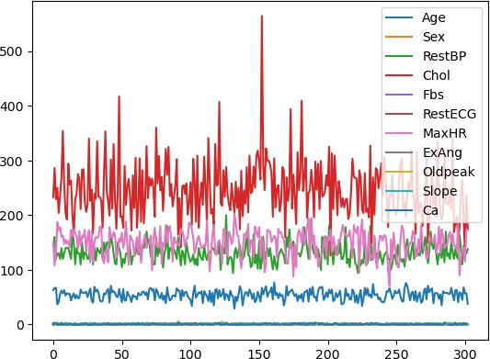

In [45]:

dataFrame**.**hist(bins **=** 10,figsize **=** (15,11));

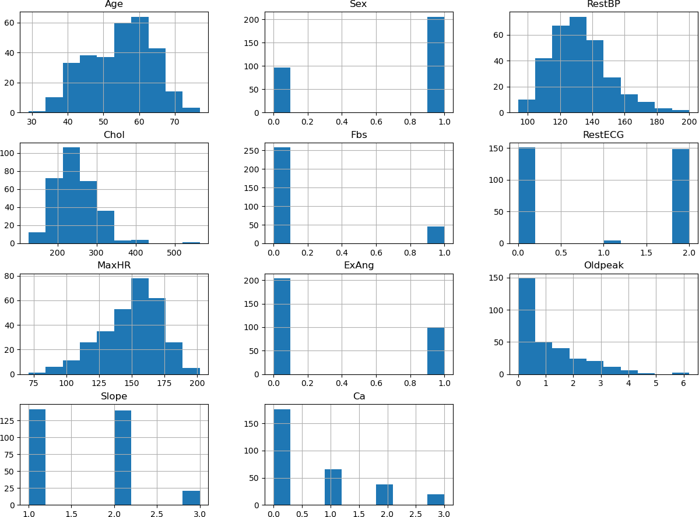

In [47]:

sns**.**pairplot(var);

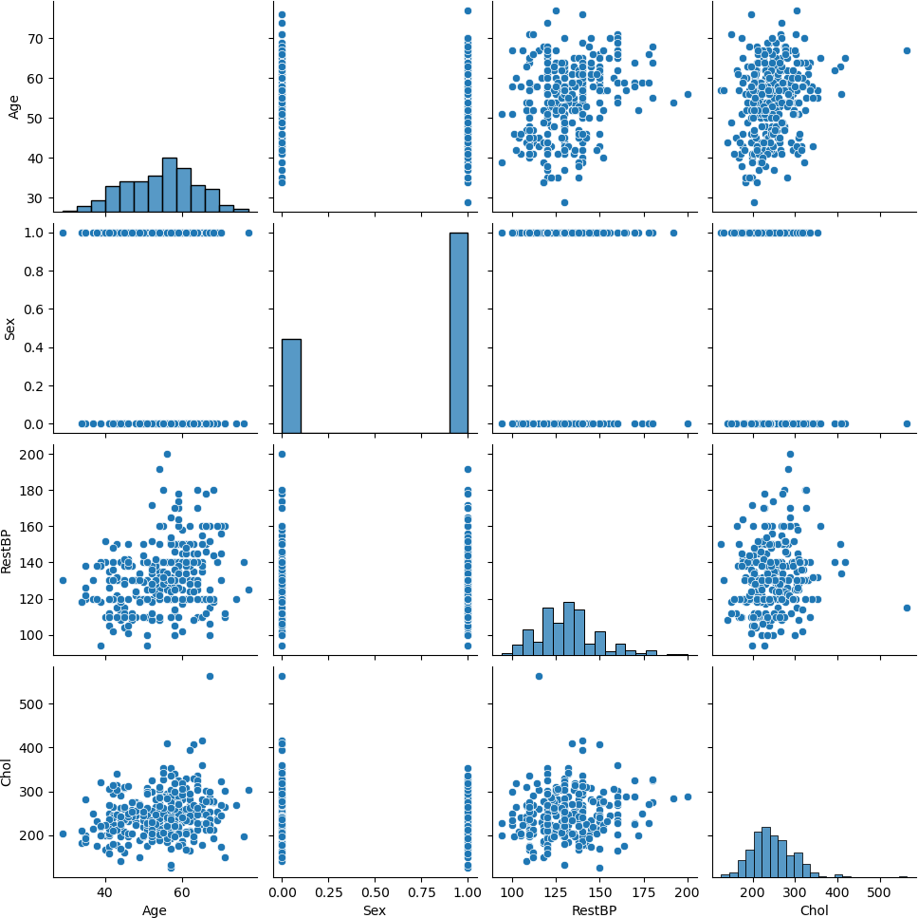

In [49]:

labels**=**['Male','Female']

dataFrame**.**Sex**.**value_counts()**.**plot(kind**=** "pie",labels **=**labels,startangle**=**90,shado

explode**=**(0,0),autopct**=**'%1.1f%%' );

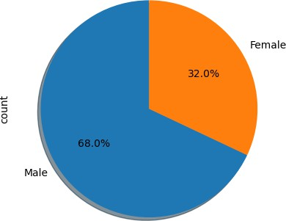

In [51]:

plt**.**hist(dataFrame["Age"],bins**=**15,label**=**"Age Count") plt**.**title("Age Histogram")

plt**.**xlabel("Age range")

plt**.**ylabel("Count according to Age") plt**.**legend(loc**=**"upper left");

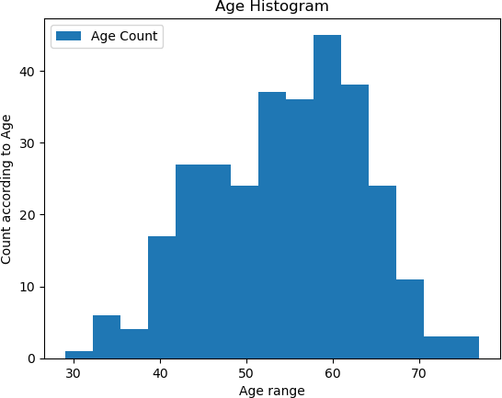

In [53]:

sns**.**barplot(x **=** "Slope", y **=** "Age", hue **=** "Sex", data **=** dataFrame) plt**.**title("Slope Group - Count Bar Plot Grouped by Sex")

plt**.**show()

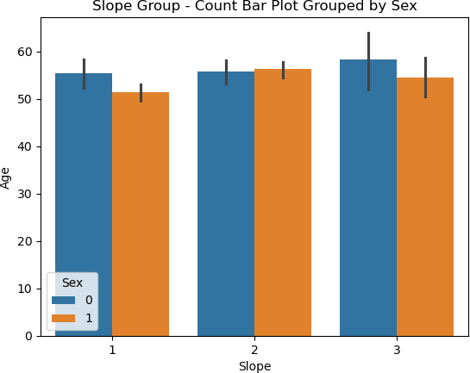

In [55]:

sns**.**barplot(x **=** "Ca", y **=** "Chol", hue **=** "Slope", data **=** dataFrame) plt**.**title("Ca Group - Count Bar Plot Grouped by Slope")

plt**.**show()

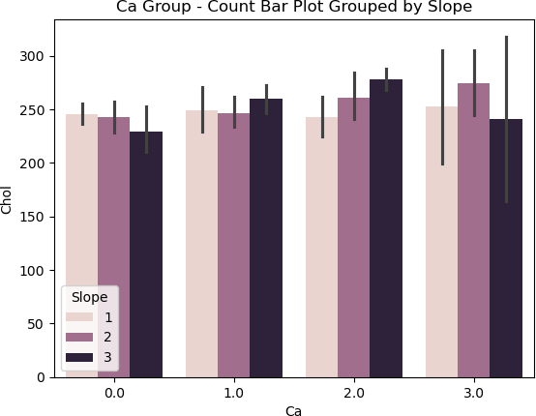

In [57]:

plt**.**scatter(dataFrame["RestBP"],dataFrame["Age"],label**=**"BP level according to Ag plt**.**title("BP vs Age Scatterplot")

plt**.**xlabel("Rest BP level") plt**.**ylabel("Age")

plt**.**legend(loc**=**"lower right");

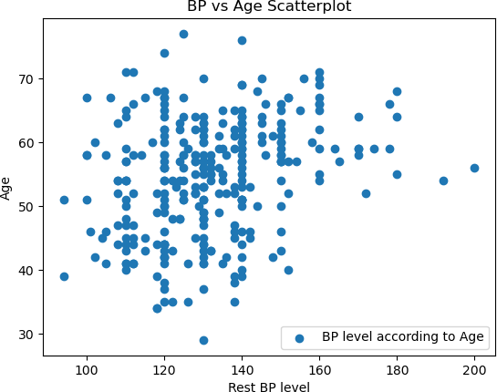

In [ ]: